Bottom of Form

**Promotion: Integrated Marketing Communication (IMC)**

**By:- Ashumani Bhatia, Faculty, MBA Deptt., HIMT, Rohtak**

**[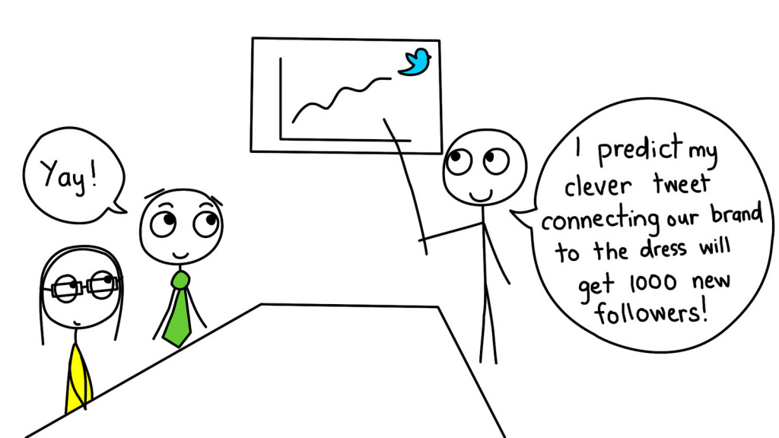](https://s3-us-west-2.amazonaws.com/courses-images-archive-read-only/wp-content/uploads/sites/903/2016/01/23230340/16725299326_f878e46b7e_h.jpg)**

**Integrated Marketing Communication (IMC) Definition**

**IMC: Making an Impact with Marketing Communication**

Having a great product available to your customers at a great price does absolutely nothing for you if your customers don’t know about it. That’s where promotion enters the picture: it does the job of connecting with your target audiences and communicating what you can offer them.

In today’s marketing environment, promotion involves *integrated marketing communication* (IMC).  In a nutshell, IMC involves bringing together a variety of different communication tools to deliver a common message and make a desired impact on customers’ perceptions and behavior. As an experienced consumer in the English-speaking world, you have almost certainly been the target of IMC activities. (Practically every time you “like” a TV show, article, or a meme on Facebook, you are participating in an IMC effort!)

**What Is Marketing Communication?**

Defining marketing communication is tricky because, in a real sense, everything an organization does has communication potential. The price placed on a product communicates something very specific about the product. A company that chooses to distribute its products strictly through discount stores sends a distinct message to the market. Marketing communication refers to activities deliberately focused on promoting an offering among target audiences. The following definition helps to clarify this term:

Marketing communication includes all the messages, media, and activities used by an organization to communicate with the market and help persuade target audiences to accept its messages and take action accordingly.

***Integrated marketing communication*** is the the process of coordinating all this activity across different communication methods. Note that a central theme of this definition is *persuasion*: persuading people to believe something, to desire something, and/or to do something. Effective marketing communication is goal directed, and it is aligned with an organization’s marketing strategy. It aims to deliver a particular message to a specific audience with a targeted purpose of altering perceptions and/or behavior. Integrated marketing communication (IMC) makes this marketing activity more efficient and effective because it relies on multiple communication methods and customer touch points to deliver a consistent message in more ways and in more compelling ways.

**The Promotion Mix: Marketing Communication Methods**

The ***promotion mix*** refers to how marketers combine a range of marketing communication methods to execute their marketing activities. Different methods of marketing communication have distinct advantages and complexities, and it requires skill and experience to deploy them effectively. Not surprisingly, marketing communication methods evolve over time as new communication tools and capabilities become available to marketers and the people they target.

**[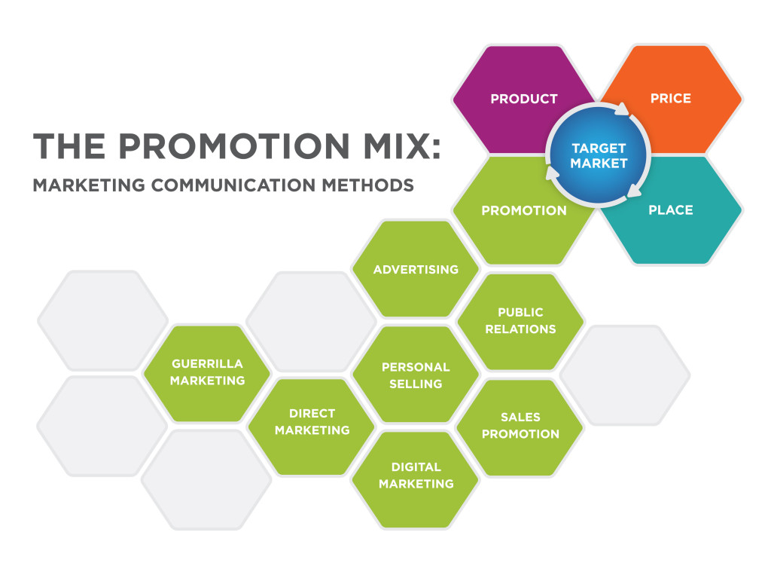](https://s3-us-west-2.amazonaws.com/courses-images-archive-read-only/wp-content/uploads/sites/903/2016/02/23230451/Promotion-Mix-Graphic-final.jpg)**

Seven common methods of marketing communication are described below:

* **Advertising:** Any paid form of presenting ideas, goods, or services by an identified sponsor. Historically, advertising messages have been tailored to a group and employ mass media such as radio, television, newspaper, and magazines. Advertising may also target individuals according to their profile characteristics or behavior; examples are the weekly ads mailed by supermarkets to local residents or online banner ads targeted to individuals based on the sites they visit or their Internet search terms.
* **Public relations (PR):** The purpose of public relations is to create goodwill between an organization (or the things it promotes) and the “public” or target segments it is trying to reach. This happens through unpaid or earned promotional opportunities: articles, press and media coverage, winning awards, giving presentations at conferences and events, and otherwise getting favorable attention through vehicles not paid for by the sponsor. Although organizations earn rather than pay for the PR attention they receive, they may spend significant resources on the activities, events, and people who generate this attention.
* **Personal selling:** Personal selling uses people to develop relationships with target audiences for the purpose of selling products and services. Personal selling puts an emphasis on face-to-face interaction, understanding the customer’s needs, and demonstrating how the product or service provides value.
* **Sales promotion:** Sales promotions are marketing activities that aim to temporarily boost sales of a product or service by adding to the basic value offered, such as “buy one get one free” offers to consumers or “buy twelve cases and get a 10 percent discount” to wholesalers, retailers, or distributors.
* **Direct marketing:** This method aims to sell products or services directly to consumers rather than going through retailer. Catalogs, telemarketing, mailed brochures, or promotional materials and television home shopping channels are all common traditional direct marketing tools. Email and mobile marketing are two next-generation direct marketing channels.
* **Digital marketing:** Digital marketing covers a lot of ground, from Web sites to search-engine, content, and social media marketing. Digital marketing tools and techniques evolve rapidly with technological advances, but this umbrella term covers all of the ways in which digital technologies are used to market and sell organizations, products, services, ideas, and experiences.
* **Guerrilla marketing:** This newer category of marketing communication involves unconventional, innovative, and usually low-cost marketing tactics to engage consumers in the marketing activity, generate attention and achieve maximum exposure for an organization, its products, and/or services. Generally guerrilla marketing is experiential: it creates a novel situation or memorable experience consumers connect to a product or brand.

**[](https://s3-us-west-2.amazonaws.com/courses-images-archive-read-only/wp-content/uploads/sites/903/2016/01/23230331/mcsign_jpg__544%C3%97725_.jpg)**

Guerrilla marketing: a lamppost transformed into a McDonald’s coffeepot. Source: http://janjan-design.blogspot.com/2012/06/im-loving-it.html

Most marketing initiatives today incorporate multiple methods: hence the need for IMC. Each of these marketing communication methods will be discussed in further detail later in this chapter.

**The Objectives of Marketing Communication**

The basic objectives of all marketing communication methods are (1) to communicate, (2) to compete, and (3) to convince. In order to be effective, organizations should ensure that whatever information they communicate is clear, accurate, truthful, and useful to the stakeholders involved. In fact, being truthful and accurate in marketing communications is more than a matter of integrity; it’s also a matter of legality, since fraudulent marketing communications can end in lawsuits and even the criminal justice system.

Marketing communication is key to competing effectively, particularly in markets where competitors sell essentially the same product at the same price in the same outlets. Only through marketing communications may an organization find ways to appeal to certain segments, differentiate its product, and create enduring brand loyalty. Remaining more appealing or convincing than competitors’ messages is an ongoing challenge.

Ideally, marketing communication is convincing: it should present ideas, products, or services in such a compelling way that target segments are led to take a desired action. The ability to persuade and convince is essential to winning new business, but it may also be necessary to reconvince and retain many consumers and customers. Just because a customer buys a particular brand once or a dozen times, or even for a dozen years, there is no guarantee that the person will stick with the original product. That is why marketers want to make sure he or she is constantly reminded of the product’s unique benefits.

**Marketing Campaigns and IMC**

**The Marketing Campaign**

**[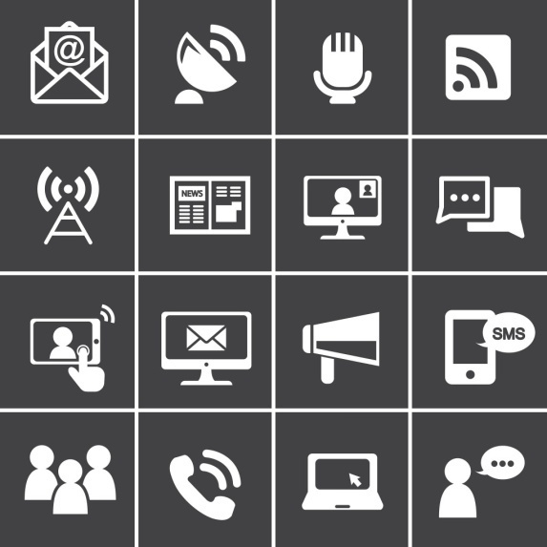](https://s3-us-west-2.amazonaws.com/courses-images-archive-read-only/wp-content/uploads/sites/903/2016/02/23230436/16474896040_e4990bf9c9_k.jpg)**

Determining which marketing communication methods and tools to use and how best to combine them is a challenge for any marketer planning a promotional strategy. To aid the planning process, marketing managers often use a campaign approach.  A *campaign* is a planned, coordinated series of marketing communication efforts built around a single theme or idea and designed to reach a particular goal. For years, the term “campaign” has been used in connection with advertising, and this term applies equally well to the entire IMC program.

Organizations may conduct many types of IMC campaigns, and several may be run concurrently. Geographically, a firm may have a local, regional, or national campaign, depending upon the available funds, objectives, and market scope. One campaign may be aimed at consumers and another at wholesalers and retailers. Different marketing campaigns might target different segments simultaneously, delivering messages and using communication tools tailored to each segment. Marketers use a marketing plan (sometimes called an IMC plan) to track and execute a set of campaigns over a given period of time.

A campaign revolves around a theme, a central idea, focal point, or purpose. This theme permeates all IMC efforts and works to unify the campaign. The theme may refer to the campaign’s goals—for example, KCRW “Capital Campaign” launched by the popular Los Angeles-based public radio station KCRW to raise $48 million to build a new state-of-the-art media facility for its operations. The theme may also refer to the shift in customer attitudes or behavior that a campaign focuses on—such as new-member campaigns launched by numerous member organizations, from professional associations to school parent-teacher organizations. A theme might take the form of a slogan, such as Coca-Cola’s “Taste the Feeling” campaign or DeBeers’ “A diamond is forever.”

Clear Channel is a marketing company that specializes in outdoor advertising. For their latest advertising campaign in Switzerland, they created a slogan-based theme, “Where Brands Meet People,” and asked their clients to participate in dramatizing it. Dozens of Swiss companies gave their logo to be used as individual “tiles” in three colorful mosaic portraits. These mosaics, that, appeared on the Web and on the streets of Switzerland. **[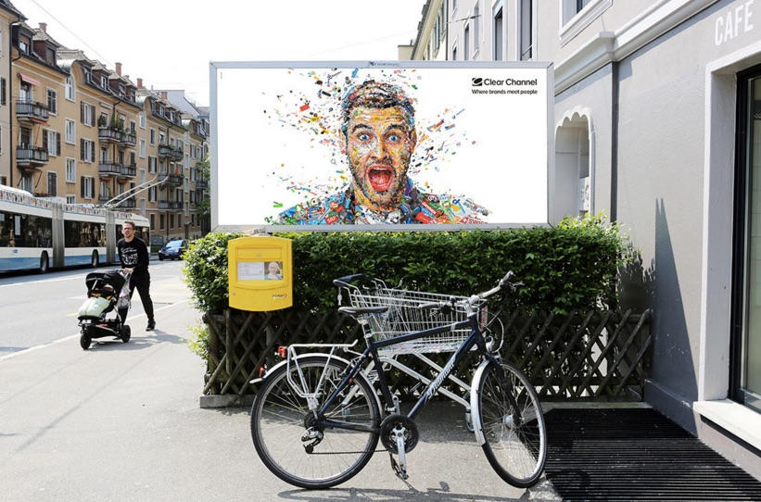](https://s3-us-west-2.amazonaws.com/courses-images-archive-read-only/wp-content/uploads/sites/903/2016/01/23230335/Clear_Channel__Where_brands_meet_people_on_Behance-1.jpg)**

Marketing campaigns may also adopt themes that refer to a stage in the product life cycle, such as McDonald’s 2015 “All-Day Breakfast” rollout campaign. Some organizations use the same theme for several campaigns; others develop a different theme for each new campaign.

In a successfully operated campaign, all activities will be well coordinated to build on one another and increase the overall impact. For example, a single campaign might include:

* **Advertising:** A series of related, well-timed, carefully placed television ads coupled with print advertising in selected magazines and newspapers
* **Direct marketing:** Direct-to-consumer mail pieces sent to target segments in selected geographic areas, reinforcing the messages from the ads
* **Personal selling:** Preparation for customer sales representatives about the campaign to equip them to explain and demonstrate the product benefits stressed in advertising
* **Sales promotions:** In-store display materials reflecting the same messages and design as the ads, emphasizing point-of-sale impact
* **Digital marketing:** Promotional information on the organization’s Web site that reflects the same messages, design, and offers reflected in the ads; ads themselves may be posted on the Website, YouTube, Facebook, and shared in other social media
* **Public relations:** A press release announcing something newsworthy in connection to the campaign focus, objectives, and target segment(s)

For each IMC campaign, new display materials must be prepared, all reflecting common objectives, messages, design, and other elements to maximize the campaign’s impact.

People responsible for the physical delivery of the products or services must ensure that the distribution points are well stocked and equipped to deliver in all outlets prior to the start of the campaign. People managing public and media relations should be constantly kept aware of marketing planning, allowing them to identify and coordinate opportunities for earned media attention. Because public relations deals with media, conference/event organizers, and other stakeholders outside the organization, it is extremely important to give enough lead time for the public relations effort to take advantage of optimal timing in support of the overall campaign.

**Advertising**

**[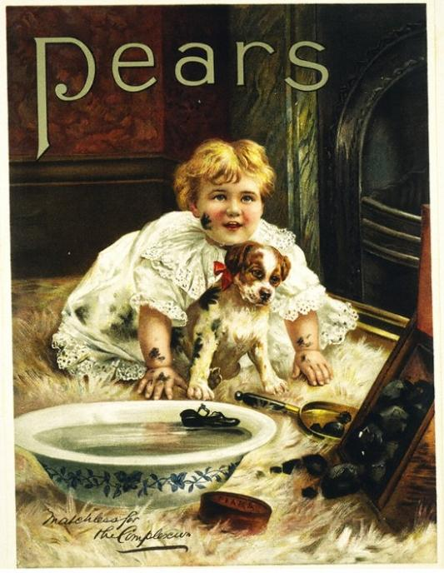](https://s3-us-west-2.amazonaws.com/courses-images-archive-read-only/wp-content/uploads/sites/903/2016/02/23230352/Pears_Soap_1900.jpg)**

A 1900 advertisement for Pears soap.

Advertising is any paid form of communication from an identified sponsor or source that draws attention to ideas, goods, services or the sponsor itself. Most advertising is directed toward groups rather than individuals, and advertising is usually delivered through media such as television, radio, newspapers and, increasingly, the Internet. Ads are often measured in *impressions*(the number of times a consumer is exposed to an advertisement).

Advertising is a very old form of promotion with roots that go back even to ancient times. In recent decades, the practices of advertising have changed enormously as new technology and media have allowed consumers to bypass traditional advertising venues. From the invention of the remote control, which allows people to ignore advertising on TV without leaving the couch, to recording devices that let people watch TV programs but skip the ads, conventional advertising is on the wane. Across the board, television viewership has fragmented, and ratings have fallen.

Print media are also in decline, with fewer people subscribing to newspapers and other print media and more people favoring digital sources for news and entertainment. Newspaper advertising revenue has declined steadily since 2000.[**[2]**](https://courses.lumenlearning.com/wmopen-introbusiness/chapter/promotion-integrated-marketing-communication-imc/#footnote-7419-2) Advertising revenue in television is also soft, and it is split across a growing number of broadcast and cable networks. Clearly companies need to move beyond traditional advertising channels to reach consumers. Digital media outlets have happily stepped in to fill this gap. Despite this changing landscape, for many companies advertising remains at the forefront of how they deliver the proper message to customers and prospective customers.

**The Purpose of Advertising**

Advertising has three primary objectives: to inform, to persuade, and to remind.

* **Informative Advertising** creates awareness of brands, products, services, and ideas. It announces new products and programs and can educate people about the attributes and benefits of new or established products.
* **Persuasive Advertising** tries to convince customers that a company’s services or products are the best, and it works to alter perceptions and enhance the image of a company or product. Its goal is to influence consumers to take action and switch brands, try a new product, or remain loyal to a current brand.
* **Reminder Advertising** reminds people about the need for a product or service, or the features and benefits it will provide when they purchase promptly.

**[](https://s3-us-west-2.amazonaws.com/courses-images-archive-read-only/wp-content/uploads/sites/903/2016/02/23230429/rogue_and_naked.png)**

**Left:** Informative Advertising **Right:** Persuasive Advertising

**[](https://s3-us-west-2.amazonaws.com/courses-images-archive-read-only/wp-content/uploads/sites/903/2016/02/23230413/Gotmilk.png)**

Reminder Advertising

When people think of advertising, often **product-focused advertisements** are top of mind—i.e., ads that promote an organization’s goods or services. **Institutional advertising** goes beyond products to promote organizations, issues, places, events, and political figures. **Public service announcements (PSAs)** are a category of institutional advertising focused on social-welfare issues such as drunk driving, drug use, and practicing a healthy lifestyle. Usually PSAs are sponsored by nonprofit organizations and government agencies with a vested interest in the causes they promote.

**[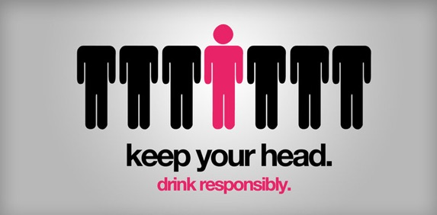](https://s3-us-west-2.amazonaws.com/courses-images-archive-read-only/wp-content/uploads/sites/903/2016/02/23230411/resadv36_jpg__580%C3%97290_.jpg)**

Public Service Announcement (PSA)

**Advantages and Disadvantages of Advertising**

As a method of marketing communication, advertising has both advantages and disadvantages. In terms of advantages, advertising creates a sense of credibility or legitimacy when an organization invests in presenting itself and its products in a public forum. Ads can convey a sense of quality and permanence, the idea that a company isn’t some fly-by-night venture. Advertising allows marketers to repeat a message at intervals selected strategically. Repetition makes it more likely that the target audience will see and recall a message, which improves awareness-building results. Advertising can generate drama and human interest by featuring people and situations that are exciting or engaging. It can introduce emotions, images, and symbols that stimulate desire, and it can show how a product or brand compares favorably to competitors. Finally, advertising is an excellent vehicle for brand building, as it can create rational and emotional connections with a company or offering that translate into goodwill. As advertising becomes more sophisticated with digital media, it is a powerful tool for tracking consumer behaviors, interests, and preferences, allowing advertisers to better tailor content and offers to individual consumers. Through the power of digital media, memorable or entertaining advertising can be shared between friends and go viral—and viewer impressions skyrocket.

The primary disadvantage of advertising is cost. Marketers question whether this communication method is really cost-effective at reaching large groups. Of course, costs vary depending on the medium, with television ads being very expensive to produce and place. In contrast, print and digital ads tend to be much less expensive. Along with cost is the question of how many people an advertisement actually reaches. Ads are easily tuned out in today’s crowded media marketplace. Even ads that initially grab attention can grow stale over time. While digital ads are clickable and interactive, traditional advertising media are not. In the bricks-and-mortar world, it is difficult for marketers to measure the success of advertising and link it directly to changes in consumer perceptions or behavior. Because advertising is a one-way medium, there is usually little direct opportunity for consumer feedback and interaction, particularly from consumers who often feel overwhelmed by competing market messages.

**Developing Effective Ads: The Creative Strategy**

Effective advertising starts with the same foundational components as any other IMC campaign: identifying the target audience and the objectives for the campaign. When advertising is part of a broader IMC effort, it is important to consider the strategic role advertising will play relative to other marketing communication tools. With clarity around the target audience, campaign strategy, and budget, the next step is to develop the **creative strategy** for developing compelling advertising. The creative strategy has two primary components: the *message* and the *appeal*.

The **message** comes from the messaging framework: What message elements should the advertising convey to consumers? What should the key message be? What is the call to action? How should the brand promise be manifested in the ad? How will it position and differentiate the offering? With advertising, it’s important to remember that the ad can communicate the message not only with words but also potentially with images, sound, tone, and style.

**[](https://s3-us-west-2.amazonaws.com/courses-images-archive-read-only/wp-content/uploads/sites/903/2016/02/23230419/puma_wolf_lamb_jpg__770%C3%97540_.jpg)**

Effective wordless advertisement

Marketers also need to consider existing public perceptions and other advertising and messages the company has placed in the market. Has the prior marketing activity resonated well with target audiences? Should the next round of advertising reinforce what went before, or is it time for a fresh new message, look, or tone?

Along with message, the creative strategy also identifies the **appeal**, or how the advertising will attract attention and influence a person’s perceptions or behavior. Advertising appeals can take many forms, but they tend to fall into one of two categories: *informational* appeal and *emotional* appeal.

The **informational appeal** offers facts and information to help the target audience make a purchasing decision. It tries to generate attention using rational arguments and evidence to convince consumers to select a product, service, or brand. For example:

* More or better product or service features: Ajax “Stronger Than Dirt”
* Cost savings:  Wal-Mart “Always Low Prices”
* Quality: John Deere “Nothing runs like a Deere”
* Customer service: Holiday Inn “Pleasing people the world over”
* New, improved: Verizon “Can you hear me now? Good.”

The **emotional appeal** targets consumers’ emotional wants and needs rather than rational logic and facts. It plays on conscious or subconscious desires, beliefs, fears, and insecurities to persuade consumers and influence their behavior. The emotional appeal is linked to the features and benefits provided by the product, but it creates a connection with consumers at an emotional level rather than a rational level. Most marketers agree that emotional appeals are more powerful and differentiating than informational appeals. However, they must be executed well to seem authentic and credible to the the target audience. A poorly executed emotional appeal can come across as trite or manipulative. Examples of emotional appeals include:

* Self-esteem: L’Oreal “Because I’m worth it”
* Happiness: Coca-Cola “Open happiness”
* Anxiety and fear: World Health Organization “Smoking Kills”
* Achievement: Nike “Just Do It”
* Attitude: Apple “Think Different”
* Freedom: Southwest “You are now free to move about the country”
* Peace of Mind: Allstate “Are you in good hands?”
* Popularity: NBC “Must-see TV”
* Germophobia: Chlorox “For life’s bleachable moments, there’s Chlorox”

**Public Relations**

**[](https://s3-us-west-2.amazonaws.com/courses-images-archive-read-only/wp-content/uploads/sites/903/2016/02/23230425/public_relations_-_Google_Search.jpg)**

**Public Relations: Getting Attention to Polish Your Image**

Public relations (PR) is the process of maintaining a favorable image and building beneficial relationships between an organization and the public communities, groups, and people it serves. Unlike advertising, which tries to create favorable impressions through paid messages, public relations does not pay for attention and publicity. Instead, PR strives to earn a favorable image by drawing attention to newsworthy and attention-worthy activities of the organization and its customers. For this reason, PR is often referred to as “free advertising.”

In fact, PR is not a costless form of promotion. It requires salaries to be paid to people who oversee and execute PR strategy. It also involves expenses associated with events, sponsorships and other PR-related activities.

**The Purpose of Public Relations**

Like advertising, public relations seeks to promote organizations, products, services, and brands. But PR activities also play an important role in identifying and building relationships with influential individuals and groups responsible for shaping market perceptions in the industry or product category where an organization operates. Public relations efforts strive to do the following:

* Build and maintain a positive image
* Inform target audiences about positive associations with a product, service, brand, or organization
* Maintain good relationships with *influencers—*the people who strongly influence the opinions of target audiences
* Generate goodwill among consumers, the media, and other target audiences by raising the organization’s profile
* Stimulate demand for a product, service, idea, or organization
* Head off critical or unfavorable media coverage

**When to Use Public Relations**

Public relations offers an excellent toolset for generating attention whenever there is something newsworthy that marketers would like to share with customers, prospective customers, the local community, or other audiences. PR professionals maintain relationships with reporters and writers who routinely cover news about the company, product category, and industry, so they can alert media organizations when news happens. At times, PR actually creates activities that are newsworthy, such as establishing a scholarship program or hosting a science fair for local schools. PR is involved in publishing general information about an organization, such as an annual report, a newsletter, an article, a white paper providing deeper information about a topic of interest, or an informational press kit for the media. PR is also responsible for identifying and building relationships with influencers who help shape opinions in the marketplace about a company and its products. When an organization finds itself facing a public emergency or crisis of some sort, PR professionals play an important role strategizing and managing communications with various stakeholder groups, to help the organization respond in effective, appropriate ways and to minimize damage to its public image.

To illustrate, PR techniques can help marketers turn the following types of events into opportunities for media attention, community relationship building, and improving the organization’s public image:

* Your organization develops an innovative technology or approach that is different and better than anything else available.
* One of your products wins a “best in category” prize awarded by a trade group.
* You enter into a partnership with another organization to collaborate on providing broader and more complete services to a target market segment.
* You sponsor and help organize a 10K race to benefit a local charity.
* You merge with another company.
* You conduct research to better understand attitudes and behaviors among a target segment, and it yields insights your customers would find interesting and beneficial.
* A customer shares impressive and well-documented results about the cost savings they have realized from using your products or services.
* Your organization is hiring a new CEO or other significant executive appointment.
* A quality-assurance problem leads your company to issue a recall for one of your products.

It is wise to develop a PR strategy around strengthening relationships with any group that is important in shaping or maintaining a positive public image for your organization: reporters and media organizations; industry and professional associations; bloggers; market or industry analysts; governmental regulatory bodies; customers and especially leaders of customer groups, and so forth. It is also wise to maintain regular, periodic communications with these groups to keep them informed about your organization and its activities. This helps build a foundation of familiarity and trust, so these relationships are established and resilient through the ups and downs of day-to-day business.

**Standard Public Relations Techniques**

Public relations encompasses a variety of marketing tactics that all share a common focus: managing public perceptions. The most common PR tools are listed in the following table and discussed below.

| **Public Relations Technique** | **Role and Description** | **Examples** |
| --- | --- | --- |
| Media Relations | Generate positive news coverage about the organization, its products, services, people, and activities | Press release, press kit, and interview leading to a news article about a new product launch; press conference |
| Influencer/Analyst Relations | Maintain strong, beneficial relationships with individuals who are thought leaders for a market or segment | Product review published by a renowned blogger; company profile by an industry analyst; celebrity endorsement |
| Publications and Thought Leadership | Provide information about the organization, showcase its expertise and competitive advantages | Organization’s annual report; newsletters; white papers focused on research and development; video case study about a successful customer |
| Events | Engage with a community to present information and an interactive “live” experience with a product, service, organization or brand | User conference; presentation of a keynote address; day-of-community-service event |
| Sponsorships | Raise the profile of an organization by affiliating it with specific causes or activities | Co-sponsoring an industry conference; sponsoring a sports team; sponsoring a race to benefit a charity |
| Award Programs | Generate recognition for excellence within the organization and/or among customers | Winning an industry “product of the year” award; nominating customer for an outstanding achievement award |
| Crisis Management | Manage perceptions and contain concerns in the face of an emergency situation | Oversee customer communication during a service outage or a product recall; execute action plan associated with an environmental disaster |

**Media relations** is the first thing that comes to mind when many people think of PR: public announcements about company news, talking to reporters, and articles about new developments t a company. But media relations is the tip of the iceberg. For many industries and product categories, there are influential bloggers and analysts writing about products and the industry. PR plays an important role in identifying and building relationships with these individuals. Offering periodic “company update” briefings, newsletters, or email updates helps keep these individuals informed about your organization, so you are top of mind.

The people responsible for PR are also involved in developing and distributing general information about an organization. This information may be in the form of an annual report, a “state of the company” briefing call, video pieces about the company or its customers, and other **publications** that convey the company’s identity, vision, and goals. “Thought leadership” publications assert the company’s expertise and position of leading thought, practice, or innovation in the field. These publications should always be mindful of the same messaging employed for other marketing activities to ensure that everything seems consistent and well aligned.

While some consider event marketing a marketing communication method of its own, others categorize it with public relations as we have done here. **Events**, such as industry conferences or user group meetings, offer opportunities to present the company’s value proposition, products, and services to current and prospective customers. Themed events, such as a community service day or a healthy lifestyle day, raise awareness about causes or issues with with the organization wants to be affiliated in the minds of its employees, customers, and other stakeholder groups. A well-designed and well-produced event also offers opportunities for an organization to provide memorable interaction and experiences with target audiences. An executive leader can offer a visionary speech to generate excitement about a company and the value it provides—now or in the future. Events can help cement brand loyalty by not only informing customers but also forging emotional connections and goodwill.

**Sponsorships** go hand-in-hand with events, as organizations affiliate themselves with events and organizations by signing on to co-sponsor something available to the community. Sponsorships cover the gamut: charitable events, athletes, sports teams, stadiums, trade shows and conferences, contests, scholarships, lectures, concerts, and so forth. Marketers should select sponsorships carefully to make sure that they are affiliating with activities and causes that are well managed and strategically aligned with the public image they are trying to cultivate.

**[](https://s3-us-west-2.amazonaws.com/courses-images-archive-read-only/wp-content/uploads/sites/903/2016/02/23230426/14140767473_f9fc727777_k.jpg)**

Innovation Award, sponsored by IBM and the United Nations Development Program, being given to given to Kenya’s Information and Communication Technology Authority

**Award programs** are another common PR tool. Organizations can participate in established award programs managed by trade groups and media, or they can create award programs that target their customer community. Awards provide opportunities for public recognition of great work by employees and customers. They can also help organizations identify great targets for case studies and public announcements to draw attention to how customers are benefitting from an organization’s products and services.

**Crisis management** is an important PR toolset to have on hand whenever it may be needed. Few companies choose this as a promotional technique if other options are available. But when crises emerge, as inevitably they do, PR provides structure and discipline to help company leaders navigate the crisis with communications and actions that address the needs of all stakeholders. Messaging, communication, listening, and relationship building all come to the fore. When handled effectively, these incidents may help an organization emerge from the crisis stronger and more resilient than it was before. This is the power of good PR.

**Advantages and Disadvantages of Public Relations**

Because PR activity is earned rather than paid, it tends to carry more credibility and weight. For example, when a news story profiles a customer’s successful experience with a company and its products, people tend to view this type of article as less biased (and therefore more credible) than a paid advertisement. The news story comes from an objective reporter who feels the story is worth telling. Meanwhile an advertisement on a similar topic would be viewed with skepticism because it is a paid placement from a biased source: the ad sponsor.

**Advantages of Public Relations**

1. **The opportunity to amplify key messages and milestones.**When PR activities are well-aligned with other marketing activities, organizations can use PR to amplify the things they are trying to communicate via other channels. A press release about a new product, for example, can be timed to support a marketing launch of the product and conference where the product is unveiled for the first time.
2. **Believable.** Because publicity is seen to be more objective, people tend to give it more weight and find it more credible. Paid advertisements, on the other hand, are seen with a certain amount of skepticism, since people that companies can make almost any kind of product claim they want.
3. **Employee pride.** Organizing and/or sponsoring charitable activities or community events can help with employee morale and pride (both of which get a boost from any related publicity, too). It can also be an opportunity for teamwork and collaboration.
4. **Engaging people who visit your Web site.** PR activities can generate interesting content that can be featured on your organization’s Web site. Such information can be a means of engaging visitors to the site, and it can generate interest and traffic long after the PR event or moment has passed. Industry influencers may visit the site, too, to get updates on product developments, growth plans, or personnel news, etc.

**Disadvantages of Public Relations**

1. **Cost.** Although publicity is usually less expensive to organize than advertising, it isn’t “free.” A public relations firm may need to be hired to develop campaigns, write press releases, and speak to journalists. Even if you have in-house expertise for this work, developing publicity materials can take employees away from their primary responsibilities and drain off needed resources.
2. **Lack of control.** There’s no guarantee that a reporter or industry influencer will give your company or product a favorable review—it’s the price you pay for “unbiased” coverage. You also don’t have any control over the accuracy or thoroughness of the coverage.  There’s always a risk that the journalist will get some facts wrong or fail to include important details.
3. **Missing the mark.** Even if you do everything right—you pull off a worthy event and it gets written up by a local newspaper, say—your public relations effort can fall short and fail to reach enough or the right part of your target audience. It doesn’t do any good if the reporter’s write-up is very short or it appears in a section of the paper that no one reads. This is another consequence of not being able to fully control the authorship, content, and placement of PR.

**Sales Promotions**

**Getting Action Now**

**[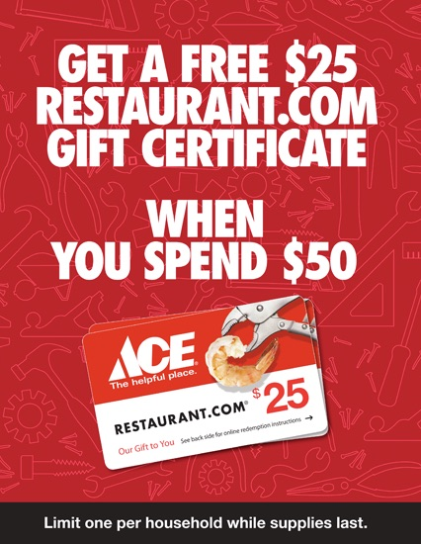](https://s3-us-west-2.amazonaws.com/courses-images-archive-read-only/wp-content/uploads/sites/903/2016/02/23230404/print-ace-pop_png__430%C3%97555_.jpg)**

Sales promotions are a marketing communication tool for stimulating revenue or providing incentives or extra value to distributers, sales staff, or customers over a short time period. Sales promotion activities include special offers, displays, demonstrations, and other nonrecurring selling efforts that aren’t part of the ordinary routine. As an additional incentive to buy, these tools can be directed at consumers, retailers and other distribution partners, or the manufacturer’s own sales force.

Companies use many different forms of media to communicate about sales promotions, such as printed materials like posters, coupons, direct mail pieces and billboards; radio and television ads; digital media like text messages, email, websites and social media, and so forth.

Companies use sales promotions to increase demand for their products and services, improve product availability among distribution channel partners, and to coordinate selling, advertising, and public relations. A successful sales promotion tries to prompt a target segment to show interest in the product or service, try it, and ideally buy it and become loyal customers.

There are two types of sales promotions: consumer and trade. A consumer sales promotion targets the consumer or end-user buying the product, while a trade promotion focuses on organizational customers that can stimulate immediate sales.

**Consumer Sales Promotion Techniques**

**[](https://s3-us-west-2.amazonaws.com/courses-images-archive-read-only/wp-content/uploads/sites/903/2016/02/23230408/4948232118_bab9070cd8_o.jpg)**

Free samples of Starbucks Mocha Toffee Latte

Most consumers are familiar with common sales promotion techniques including samples, coupons, point-of-purchase displays, premiums, contents, loyalty programs and rebates.

Do you like free samples? Most people do. A **sample** is a sales promotion in which a small amount of a product that is for sale is given to consumers to try. Samples encourage trial and an increased awareness of the product. You have probably purchased a product that included a small free sample with it—for example, a small amount of conditioner packaged with your shampoo. Have you ever gone to a store that provided free samples of different food items? The motivation behind giving away samples is to get people to buy a product. Although sampling is an expensive strategy, it is usually very effective for food products. People try the product, the person providing the sample tells consumers about it, and mentions any special pricing or offers for the product.

Often paired with samples are coupons. **Coupons** provide an immediate price reduction off an item. The amount of the coupon is later reimbursed to the retailer by the manufacturer. The retailer also gets a handling fee for accepting coupons. When the economy is weak, more consumers collect coupons and look for special bargains such as double coupons and buy-one-get-one-free (BOGO) coupons. While many consumers cut coupons from the inserts in Sunday newspapers, other consumers find coupons for products and stores online. Stores may also provide coupons for customers with a loyalty card.

Consumers can download coupons on many mobile phones. Mobile marketing and the Internet give consumers in international markets access to coupons and other promotions. In India, the majority of coupons used are digital, while paper coupons still have the largest share in the United States. More than 80 percent of diapers are purchased with coupons; imagine how much easier and less wasteful digital coupons scanned from a mobile phone are for both organizations and consumers.

**Point-of-purchase displays**encourage consumers to buy a product immediately. These displays draw attention to a product by giving it special placement and signage. Coupon machines placed in stores are a type of point-of-purchase display. When a consumer sees a special display or can get a coupon instantly, manufacturers hope the easy availability or the discount will convince them to buy, increasing overall sales in the process.

A variety of different sales promotions are conducted online. Common online consumer sales promotions include incentives such as free items, special pricing for product bundles (buying multiple products together), free shipping, coupons, and sweepstakes. For example, many online merchants such as Bluefly and Zappos offer free shipping and free return shipping to encourage consumers to shop online. Some companies have found that response rates for online sales promotions are better than response rates for traditional sales promotions.

Another very popular sales promotion for consumers is a premium. A **premium** is a product or offer a consumer receives when they buy another product. Premiums may be offered free or for a small shipping and handling charge with proof of purchase (sales receipt or part of package). Remember wanting your favorite cereal because there was a toy in the box? The toy is an example of a premium. Some premiums are designed to motivate consumers to a buy product multiple times. What many people don’t realize is that when they pay the shipping and handling charges, they may also be paying for the premium.

Contests and sweepstakes are also popular consumer sales promotions. **Contests** are games of skill offered by a company, that offer consumers the chance to win a prize. Cheerios’ *Spoonfuls of Stories* contest, for example, invited people to submit an original children’s story and the chance to win money and the opportunity to have their story published.  **Sweepstakes** are games of chance people enter for the opportunity to win money or prizes. Sweepstakes are often structured as some variation on a random drawing.  The companies and organizations that conduct these activities hope consumers will not only enter their games, but also buy more of their products and ideally share their information for future marketing purposes. As the following video shows, marketers have become increasingly sophisticated in the way they approach this “gaming” aspect of sales promotions.

**Loyalty programs** are sales promotions designed to get repeat business. Loyalty programs include things such as frequent flier programs, hotel programs, and shopping cards for grocery stores, drugstores, and restaurants. Sometimes point systems are used in conjunction with loyalty programs. After you accumulate so many miles or points, an organization might provide you with a special incentive such as a free flight, free hotel room, or free sandwich. Many loyalty programs, especially hotel and airline programs, have partners to give consumers more ways to accumulate and use miles and points.

**Rebates** are popular with both consumers and the manufacturers that provide them. When you get a rebate, you are refunded part (or all) of the purchase price of a product after completing a form and sending it to the manufacturer with your proof of purchase. The trick is completing the paperwork on time. Many consumers forget or wait too long to do so and, as a result, don’t get any money back. This is why rebates are also popular with manufacturers. Rebates sound great to consumers until they forget to mail them in.

**[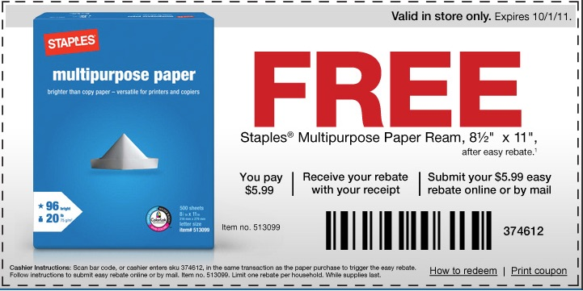](https://s3-us-west-2.amazonaws.com/courses-images-archive-read-only/wp-content/uploads/sites/903/2016/02/23230405/staples-free-ream-of-paper-after-easy-rebate_png__726%C3%97365_.jpg)**

**Which Sales Promotions Work Best, and When?**

The table, below, summarizes the different types of sales promotions designed for both consumers and businesses. Although different types of sales promotions work best for different organizations, rebates are very profitable for companies because, as you have learned, many consumers forget to send in their rebate forms. In a weak economy, consumers tend to use more coupons, but they also buy more store brands. Coupons available online or at the point of purchase are being used more often by consumers. Trade shows can be very successful, although the companies that participate in them need to follow-up on the leads generated at the shows.

| **Consumer Sales Promotions** | **B2B Sales Promotions** |
| --- | --- |
| Coupons | Trade shows and conventions |
| Sweepstakes or contests | Sales contests |
| Premiums | Trade and advertising allowances |
| Rebates | Product demonstrations |
| Samples | Training |
| Loyalty programs | Free merchandise |
| Point-of-purchase displays | Push money |

**Advantages and Disadvantages of Sales Promotions**

In addition to their primary purpose of boosting sales in the near term, companies can use consumer sales promotions to help them understand price sensitivity. Coupons and rebates provide useful information about how pricing influences consumers’ buying behavior. Sales promotions can also be a valuable–and sometimes sneaky–way to acquire contact information for current and prospective customers. Many of these offers require consumers to provide their names and other information in order to participate. Electronically-scanned coupons can be linked to other purchasing data, to inform organizations about buying habits. All this information can be used for future marketing research, campaigns and outreach.

Consumer sales promotions can generate loyalty and enthusiasm for a brand, product, or service. Frequent flyer programs, for example, motivate travelers to fly on a preferred airline even if the ticket prices are somewhat higher. If sales have slowed, a promotion such as a sweepstakes or contest can spur customer excitement and (re)new interest in the company’s offering. Sales promotions are a good way of energizing and inspiring customer action.

Trade promotions offer distribution channel partners financial incentives that encourage them to support and promote a company’s products. Offering incentives like prime shelf space at a retailer’s store in exchange for discounts on products has the potential to build and enhance business relationships with important distributors or businesses. Improving these relationships can lead to higher sales, stocking of other product lines, preferred business terms and other benefits.

Sales promotions can be a two-edged sword: if a company is continually handing out product samples and coupons, it can risk tarnishing the company’s brand. Offering too many freebies can signal to customers that they are not purchasing a prestigious or “limited” product. Another risk with too-frequent promotions is that savvy customers will hold off purchasing until the next promotion, thus depressing sales.

Often businesses rush to grow quickly by offering sales promotions, only to see these promotions fail to reach their sales goals and target customers. The temporary boost in short term sales may be attributed to highly price-sensitive consumers looking for a deal, rather than the long-term loyal customers a company wants to cultivate. Sales promotions need to be thought through, designed and promoted carefully. They also need to align well with the company’s larger business strategy. Failure to do so can be costly in terms of dollars, profitability and reputation.

If businesses become overly reliant on sales growth through promotions, they can get trapped in short-term marketing thinking and forget to focus on long-term goals. If, after each sales dip, a business offers another sales promotion, it can be damaging to the long-term value of its brand.

**Personal Selling**

**[](https://s3-us-west-2.amazonaws.com/courses-images-archive-read-only/wp-content/uploads/sites/903/2016/02/23230438/13780153345_5c09bc84de_b.jpg)**

**Personal Selling: People Power**

Personal selling uses in-person interaction to sell products and services. This type of communication is carried out by sales representatives, who are the personal connection between a buyer and a company or a company’s products or services. Salespeople not only inform potential customers about a company’s product or services, they also use their power of persuasion and remind customers of product characteristics, service agreements, prices, deals, and much more. In addition to enhancing customer relationships, this type of marketing communications tool can be a powerful source of customer feedback, as well. Later we’ll cover marketing alignment with the sales process in greater detail. This section focuses on personal selling as one possible tool in the promotional mix.

Effective personal selling addresses the buyer’s needs and preferences without making him or her feel pressured. Good salespeople offer advice, information, and recommendations, and they can help buyers save money and time during the decision process. The seller should give honest responses to any questions or objections the buyer has and show that he cares more about meeting the buyer’s needs than making the sale. Attending to these aspects of personal selling contributes to a strong, trusting relationship between buyer and seller.

**Common Personal Selling Techniques**

Common personal selling tools and techniques include the following:

* **Sales presentations**: in-person or virtual presentations to inform prospective customers about a product, service, or organization
* **Conversations**: relationship-building dialogue with prospective buyers for the purposes of influencing or making sales
* **Demonstrations**: demonstrating how a product or service works and the benefits it offers, highlighting advantageous features and how the offering solves problems the customer encounters
* **Addressing objections**: identifying and addressing the concerns of prospective customers, to remove any perceived obstacles to making a purchase
* **Field selling**: sales calls by a sales representative to connect with target customers in person or via phone
* **Retail selling**: in-store assistance from a sales clerk to help customers find, select, and purchase products that meet their needs
* **Door-to-door selling**: offering products for sale by going door-to-door in a neighborhood
* **Consultative selling**: consultation with a prospective customer, where a sales representative (or consultant) learns about the problems the customer wants to solve and recommends solutions to the customer’s particular problem
* **Reference selling**: using satisfied customers and their positive experiences to convince target customers to purchase a product or service

Personal selling minimizes wasted effort, promotes sales, and boosts word-of-mouth marketing. Also, personal selling measures marketing return on investment (ROI) better than most tools, and it can give insight into customers’ habits and their responses to a particular marketing campaign or product offer.

**When to Use Personal Selling**

Not every product or service is a good fit for personal selling. It’s an expensive technique because the proceeds of the person-to-person sales must cover the salary of the sales representative—on top of all the other costs of doing business. Whether or not a company uses personal selling as part of its marketing mix depends on its business model. Most often companies use personal selling when their products or services are highly technical, specialized, or costly—such as complex software systems, business consulting services, homes, and automobiles.

In addition, there are certain conditions that favor personal selling:[**[7]**](https://courses.lumenlearning.com/wmopen-introbusiness/chapter/promotion-integrated-marketing-communication-imc/#footnote-7419-7)

* **Product situation**: Personal selling is relatively more effective and economical when a product is of a high unit value, when it is in the introductory stage of its life cycle, when it requires personal attention to match consumer needs, or when it requires product demonstration or after-sales services.
* **Market situation**: Personal selling is effective when a firm serves a small number of large-size buyers or a small/local market. Also, it can be used effectively when an indirect channel of distribution is used for selling to agents or middlemen.
* **Company situation**: Personal selling is best utilized when a firm is not in a good position to use impersonal communication media, or it cannot afford to have a large and regular advertising outlay.
* **Consumer behavior situation**: Personal selling should be adopted by a company when purchases are valuable but infrequent, or when competition is at such a level that consumers require persuasion and follow-up.

It’s important to keep in mind that personal selling is most effective when a company has established an effective sales-force management system together with a sales force of the right design, size, and structure. Recruitment, selection, training, supervision, and evaluation of the sales force also obviously play an important role in the effectiveness of this marketing communication method.

**Advantages and Disadvantages of Personal Selling**



The most significant strength of personal selling is its flexibility. Salespeople can tailor their presentations to fit the needs, motives, and behavior of individual customers. A salesperson can gauge the customer’s reaction to a sales approach and immediately adjust the message to facilitate better understanding.

Personal selling also minimizes wasted effort. Advertisers can spend a lot of time and money on a mass-marketing message that reaches many people outside the target market (but doesn’t result in additional sales). In personal selling, the sales force pinpoints the target market, makes a contact, and focuses effort that has a strong probability of leading to a sale.

As mentioned above, an additional strength of personal selling is that measuring marketing effectiveness and determining ROI are far more straightforward for personal selling than for other marketing communication tools—where recall or attitude change is often the only measurable effect.

Another advantage of personal selling is that a salesperson is in an excellent position to encourage the customer to act. The one-on-one interaction of personal selling means that a salesperson can effectively respond to and overcome objections—e.g., concerns or reservations about the product—so that the customer is more likely to buy. Salespeople can also offer many customized reasons that might spur a customer to buy, whereas an advertisement offers a limited set of reasons that may not persuade everyone in the target audience.

A final strength of personal selling is the multiple tasks that the sales force can perform. For example, in addition to selling, a salesperson can collect payments, service or repair products, return products, and collect product and marketing information. In fact, salespeople are often the best resources when it comes to disseminating positive word-of-mouth product information.

High cost is the primary disadvantage of personal selling. With increased competition, higher travel and lodging costs, and higher salaries, the cost per sales contract continues to rise. Many companies try to control sales costs by compensating sales representatives through commissions alone, thereby guaranteeing that salespeople are paid only if they generate sales. However, commission-only salespeople may become risk averse and only call on clients who have the highest potential return. These salespeople, then, may miss opportunities to develop a broad base of potential customers that could generate higher sales revenues in the long run.

Companies can also reduce sales costs by using complementary techniques, such as telemarketing, direct mail, toll-free numbers for interested customers, and online communication with qualified prospects. Telemarketing and online communication can further reduce costs by serving as an actual selling vehicle. Both technologies can deliver sales messages, respond to questions, take payment, and follow up.

A second disadvantage of personal selling is the problem of finding and retaining high-quality people. Experienced salespeople sometimes realize that the only way their income can outpace their cost-of-living increase is to change jobs. Also, because of the push for profitability, businesses try to hire experienced salespeople away from competitors rather than hiring college graduates, who take three to five years to reach the level of productivity of more experienced salespeople. These two staffing issues have caused high turnover in many sales forces.

Another weakness of personal selling is message inconsistency. Many salespeople view themselves as independent from the organization, so they design their own sales techniques, use their own message strategies, and engage in questionable ploys to generate sales. (You’ll recall our discussion in the ethics chapter about the unique challenges that B2B salespeople face.) As a result, it can be difficult to find a unified company or product message within a sales force or between the sales force and the rest of the marketing mix.

A final disadvantage of personal selling is that sales-force members have different levels of motivation. Salespeople may vary in their willingness to make the desired number of sales calls each day; to make service calls that do not lead directly to sales; or to take full advantage of the technologies available to them.

**Direct Marketing**

**Going Straight to the Customer**

**[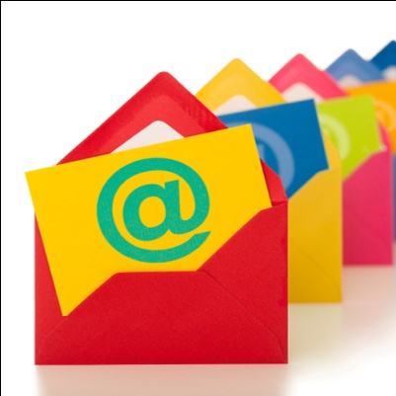](https://s3-us-west-2.amazonaws.com/courses-images-archive-read-only/wp-content/uploads/sites/903/2016/02/23230456/9162677329_ce2228febd_o-1.jpg)**

Direct marketing activities bypass any intermediaries and communicate directly with the individual consumer. Direct mail is personalized to the individual consumer, based on whatever a company knows about that person’s needs, interests, behaviors, and preferences. Traditional direct marketing activities include mail, catalogs, and telemarketing. The thousands of “junk mail” offers from credit card companies, bankers, and charitable organizations that flood mailboxes every year are artifacts of direct marketing. Telemarketing contacts prospective customers via the telephone to pitch offers and collect information. Today, direct marketing overlaps heavily with digital marketing, as marketers rely on email and, increasingly, mobile communications to reach and interact with consumers.

**The Purpose and Uses of Direct Marketing**

The purpose of direct marketing is to reach and appeal directly to individual consumers and to use information about them to offer products, services and offers that are most relevant to them and their needs. Direct marketing can be designed to support any stage of the AIDA model, from building awareness to generating interest, desire, and action. Direct marketing, particularly email, also plays a strong role in post-purchase interaction. Email is commonly used to confirm orders, send receipts or warrantees, solicit feedback through surveys, ask customers to post a social media recommendation, and propose new offers.

Direct marketing is an optimal method for marketing communication in the following situations:

* A company’s primary distribution channel is to sell products or services directly to customers
* A company’s primary distribution method is through the mail or other shipping services to send directly to the customer
* A company relies heavily on sales promotions or discounts, and it is important to spread the word about these offers to consumers
* An advertisement cannot sufficiently convey the many benefits of a company’s product or service, and so a longer marketing piece is required to express the value proposition effectively
* A company finds that standard advertising is not reaching its target segments, and so better-targeted marketing communications are required to reach the right individuals; for example, using direct mail to reach wealthier people according to their affluent zip code
* A company sells expensive products that require more information and interaction to make the sale
* A company has a known “universe” of potential customers and access to contact information and other data about these customers
* A company is heavily dependent on customer retention, reorders and/or repurchasing, making it worthwhile to maintain “permissioned” marketing interaction with known customers

**Data: The Key to Effective Direct Marketing**

The effectiveness of direct marketing activity depends on marketers using databases to capture the information of target customers and the use of this information to extend ever-more-personalized offers and information to consumers. Databases record an individual’s residence, geography, family status, and credit history. When a person moves or makes a significant purchase like a car or a home, these details become part of the criteria marketers use to identify who will be a good target for their products or services. With electronic media, the information flow about consumers opens the floodgates: marketing databases capture when a consumer opens an email message and clicks on a link. They track which links piqued consumers’ interests, what they view and visit, so that the next email offer is informed by what a person found interesting the last time around. These databases also collect credit card information, so marketers can link a person’s purchasing history to shopping patterns to further tailor communications and offers.

Mobile marketing adds another dimension of personalization in direct-to-consumer communications. It allows marketers to incorporate location-sensitive and even activity-specific information into marketing communications and offers. When marketers know you are playing a video game at a mall, thanks to your helpful smart phone, they can send you timing-, location- and activity-specific offers and messages.

**Direct Marketing in Action**

How does this work in practice? If you’ve ever paid off an auto loan, you may have noticed a torrent of mail offers from car dealerships right around the five-year mark. They know, from your credit history, that you’re nearly done paying off your car and you’ve had the vehicle for several years, so you might be interested in trading up for a newer model. Based on your geography and any voter registration information, you may be targeted during election season to participate via telephone in political polls and to receive “robocalls” from candidates and parties stomping for your vote.

Moving into the digital world, virtually any time you share an email address with an organization, it becomes part of a database to be used for future marketing. Although most organizations that engage in email marketing give the option of opting out, once you become a customer, it is easy for companies to justify continuing to contact you via email or text as part of the customer relationship you’ve established. As you continue to engage with the company, your behavior and any other information you share becomes part of the database record the company uses to segment and target you with offers it thinks will interest you.

Similarly, marketers use SMS (text) for marketing purposes, and direct marketing activity takes place in mobile apps, games, and Web sites. All of these tools use the data-rich mobile environment to capture information about consumers and turn it into productive marketing opportunities. QR codes, another direct-to-consumer mobile marketing tool, enable consumers to scan an image with a mobile phone that takes them to a Web site where they receive special information or offers.

**[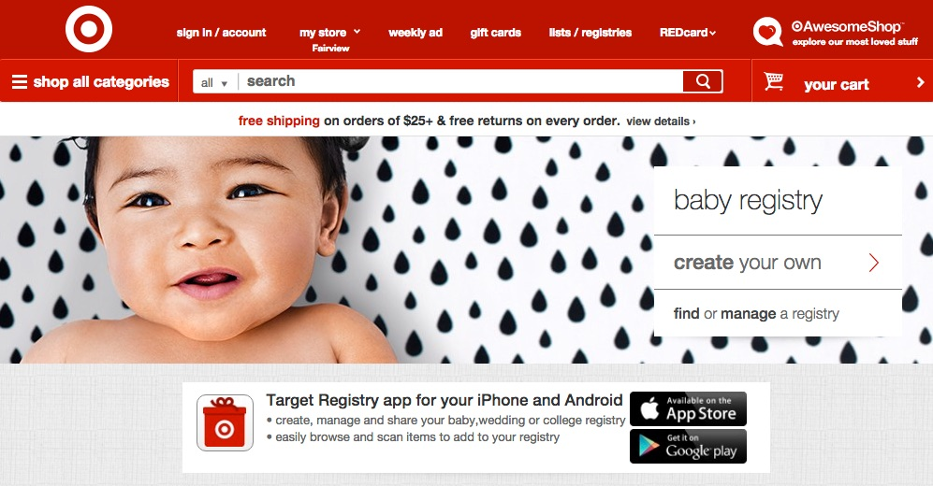](https://s3-us-west-2.amazonaws.com/courses-images-archive-read-only/wp-content/uploads/sites/903/2016/02/23230453/Baby_Registry___Target.jpg)**

**Advantages and Disadvantages of Direct Marketing**

All this data-driven direct marketing might seem a little creepy or even nefarious, and certainly it can be when marketers are insensitive or unethical in their use of consumer data. However, direct marketing also offers significant value to consumers by tailoring their experience in the market to things that most align with their needs and interests. If you’re going to have a baby (and you don’t mind people knowing about it), wouldn’t you rather have Target send you special offers on baby products than on men’s shoes or home improvement goods?

Direct marketing can be a powerful tool for anticipating and predicting customer needs and behaviors. Over time, as companies use consumer data to understand their target audiences and market dynamics, they can develop more effective campaigns and offers. Organizations can create offers that are more personalized to consumer needs and preferences, and they can reach these consumers more efficiently through direct contact. Because it is so data intensive, it is relatively easy to measure the effectiveness of direct marketing by linking it to outcomes: did a customer request additional information or use the coupons sent? Did he open the email message containing the discount offer? How many items were purchased and when? And so forth. Although the cost of database and information infrastructure is not insignificant, mobile and email marketing tend to be inexpensive to produce once the underlying infrastructure is in place. As a rule, direct marketing tactics can be designed to fit marketing budgets.

Among the leading disadvantages of direct marketing are, not surprisingly, concerns about privacy and information security. Target’s massive data breach in 2013 took a hefty toll on customer confidence, company revenue, and profitability at the time. Direct marketing also takes place in a crowded, saturated market in which people are only too willing to toss junk mail and unsolicited email into trash bins without a second glance. Electronic spam filters screen out many email messages, so people may never even see email messages from many of the organizations that send them. Heavy reliance on data also leads to the challenge of keeping databases and contact information up to date and complete, a perennial problem for many organizations. Finally, direct marketing implies a direct-to-customer business model that inevitably requires companies to provide an acceptable level of customer service and interaction to win new customers and retain their business.

**Digital Marketing: Web Sites**

**Inform, Entice, Engage**

Digital marketing is an umbrella term for using a digital tools to promote and market products, services, organizations and brands. As consumers and businesses become more reliant on digital communications, the power and importance of digital marketing have increased. The direct marketing section of this chapter already discussed two digital tools: email and mobile marketing, which fit into both categories. This section will discuss other essential tools in the digital marketing tool kit: Web sites, content marketing and search-engine optimization (SEO), and social media marketing.

**What Makes Digital Marketing Tools Unique**

In part, digital marketing is critically important because people use digital technologies frequently, and marketing needs to happen where people are. But digital marketing tools also have other unique capabilities that set them apart from traditional (predigital) marketing communication tools. These capabilities make them uniquely suited to the goals of marketing. Digital marketing tools are:

* **Interactive:** A primary focus of many digital marketing tools and efforts is to interact with target audiences, so they become actively engaged in the process, ideally at multiple points along the way. This may happen by navigating a Web site, playing a game, responding to a survey, sharing a link, submitting an email address, publishing a review, or even “liking” a post. Asking consumers to passively view an advertisement is no longer enough: now marketers look for ways to interact.
* **Mobile and portable:** Today’s digital technologies are more mobile and portable than ever before. This means digital marketing tools are also mobile and portable: consumers can access them–and they can access consumers–virtually anytime and anywhere through digital devices. Digital marketing can reach people in places and ways that simply were not possible in the past. A tired mother stuck in traffic might encourage her child to play a game on her smart phone, exposing both child and mother to marketing messages in the process. A text message sent to a remote location can remind an adventurer to renew a subscription or confirm an order. Many physical limitations fall away in the digital world.
* **Highly measurable and data driven.** Digital technologies produce mountains of data about who is doing what, when, how, and with whom. Likewise, digital marketing tools enable marketers to determine very precisely whom they want to reach, how to reach them, and what happens when people begin the process of becoming a customer. By tracking and analyzing these data, marketers can also identify which channels are most productive for bringing people into the site and what types of interactions are most efficient at turning them to customers.
* **Shareable:** Because digital marketing tools are digital, it is easy to share them at low or no cost–a benefit for marketers and for consumers who find content they want to share virally. People routinely share videos, games, Web sites, articles, images, and brands—any number of overt or covert marketing artifacts. In fact, the degree to which something is shared has become a key metric to confirm how successful it is as a marketing vehicle. Sharing has always been a primary means of spreading ideas. Digital marketing tools now facilitate extremely rapid, efficient, global sharing.
* **Synergistic with other marketing activities:** Digital marketing tools offer quick, easy, and inexpensive ways to repurpose marketing messages and content from other marketing communication methods. They help amplify and reinforce the messages targeting consumers through other media. For example, uploading a TV ad to YouTube creates a piece of digital marketing content that can be posted to Facebook, tweeted on Twitter, embedded in a Web-site page, and shared via an email from a sales representative engaged in personal selling to a target customer.

**Web-Site Marketing**

Web sites represent an all-in-one storefront, a display counter, and a megaphone for organizations to communicate in the digital world. For digital and bricks-and-mortar businesses, Web sites are a primary channel for communicating with current and prospective customers as well as other audiences. A good Web site provides evidence that an organization is real, credible, and legitimate.

**[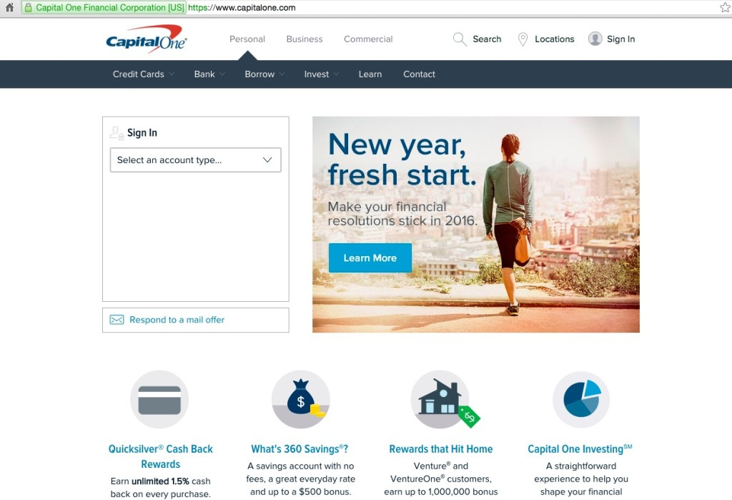](https://s3-us-west-2.amazonaws.com/courses-images-archive-read-only/wp-content/uploads/sites/903/2016/02/23230458/Capital_One_Credit_Cards__Bank__and_Loans_-_Personal_and_Business-1.jpg)**

Capital One Web Site

The variety of online Web-site-building services now available make setting up a basic Web site relatively simple and inexpensive. Once the Web site is established, it can continue to be fairly easy and inexpensive to maintain if the organization uses cost-effective and user-friendly tools. On the other hand, sophisticated Web sites can be massively expensive to build and maintain, and populating them with fresh, compelling content can devour time and money. But organizations can adjust the scope, scale, and resources required for their Web sites in proportion to their business objectives and the value they want their Web sites to deliver.

**Web Sites As Marketing Tools**

Web sites are very flexible, allowing organizations to build the kinds of features and capabilities they need to conduct business effectively. Common marketing objectives and Web-site functions include the following:

* **Providing general information** about an organization such as the value proposition, products and services, and contact information
* **Expressing the brand** of an organization through design, look and feel, personality, and voice
* **Demonstrating products, services, and expertise**, including the customer experience, features, benefits, and value they provide
* **Proof points** about the value a company offers, using evidence in the form of case studies, product reviews, testimonials, return on investment data, etc.
* **Lead generation,** capturing information about Web-site visitors to use in ongoing sales and marketing activity
* **Communities and forums** for target audiences to share information and ask/answer questions
* **Publishing value-adding content** and tools for informational or entertainment purposes to bring people in and draw them back to the Web site
* **Communication** about company news, views, culture, developments, and vision through an electronic newsroom or a company blog, for example
* **Shopping,** providing tools for customers to research, find, and select products or services in the digital environment
* **Recommendations** that direct customers to information, products, services, and companies that meet their interests and needs
* **Sales**, the ability to conduct sales and transact business online
* **Capturing customer feedback** about the organization, its products, services, content, and the Web-site experience itself

Before starting to build a Web site, the marketing manager should meet with other company leaders to lay out a common vision for what the Web site should accomplish and the business functions it should provide. For example, if a business does not plan to handle sales online, there is no need to build a “shopping cart” function or an e-commerce engine. If cultivating lively dialogue with an active customer community is an important business objective, this capability should be incorporated into the Web-site strategy and design decisions from the outset. The Web-site strategy must be effective at achieving the organization’s goals to inform, engage, entertain, explore, support, etc.

**Advantages and Disadvantages of Web-Site Marketing**

Web sites have so many advantages that there is almost no excuse for a business not to have one. Effective Web-site marketing declares to the world that an organization exists, what value it offers, and how to do business. Web sites can be an engine for generating customer data and new business leads. An electronic storefront is often dramatically less expensive than a physical storefront, and it can serve customers virtually anywhere in the world with internet access. Web sites are very flexible and easy to alter. Organizations can try out new strategies, content and tactics at relatively low cost to see what works and where the changes pay off.

At the same time, Web sites carry costs and risks. They do require some investment of time and money to set up and maintain. For many organizations, especially small organizations without a dedicated Web-site team, keeping Web-site content fresh and up-to-date is a continual challenge. Organizations should make wise, well-researched decisions about information infrastructure and Web-site hosting, to ensure their sites remain operational with good performance and uptime. Companies that capture and maintain customer data through their Web sites must be vigilant about information security to prevent hackers from stealing sensitive customer data. Some company Web sites suffer from other types of information security challenges, such as electronic vandalism, trolling (offensive or provocative online posts), and denial-of-service attacks mounted by hackers to take Web sites out of commission.

**Search-Engine Optimization and Content Marketing**

Search-engine optimization (SEO) is the process of using Internet search engines, such as Google, Bing, and Yahoo, to gain notice, visibility, and traffic from people conducting searches using these tools. SEO works in lockstep with content marketing, which takes a strategic approach to developing and distributing valuable content targeted to the interests of a defined audience, with the goal of driving sales or another profitable customer action. In other words, content marketers create worthwhile Internet content aimed at their target audiences. Then organizations use SEO tactics to get this content noticed and to generate new traffic and sales leads.

Together, SEO and content marketing can help boost awareness and brand perceptions about the value a company provides. Content marketing can help an organization gain visibility as an expert or leader in its competitive set. Together these marketing communications tools help organizations get noticed and stay top of mind among individuals seeking the types of products or services they offer.

**How SEO Works**

The basic premise behind search-engine optimization is this: People conduct Internet searches. The search terms they use bring up a given set of results. When someone is searching for the types of things your organization offers, as a marketer you want your results to be at the top. You can boost your search rankings by identifying and applying SEO and content marketing strategies to the search terms people use when they are looking for products or services like yours. It may even be worth paying to get their attention, because people searching for the things you offer are likely to be better-qualified prospective customers.

Because the supply of Internet content on any given topic is continually expanding, and because search-engine companies regularly fine-tune their search algorithms to deliver ever more helpful results, SEO is not a one-time task. It’s an ongoing process that companies should incorporate into their entire approach to digital marketing.

**How Content Marketing Works**

There is a popular saying among digital marketers: “Content is king.” Good content attracts eyeballs, while poor content does not. Content marketing is based on the premise that marketers can use Web content as a strategic asset to attract attention and drive traffic of target audiences. As a marketer, part of your job is to help the organization publish substantive Web content–articles, videos, e-books, podcasts, images, infographics, case studies, games, calculators, etc.–that will be interesting for your target segments. When you do this, you should incorporate your optimal search terms into the content, so that it’s more likely to show up in organic search results. You should also look for ways to link to that content from other Web pages, so that search-engine “bots” (or computer programs) responsible for cataloguing Web sites will think your content is popular and well regarded by the Internet-user community. As your content appears in search results, it will rank higher as more and more people click through to your content and link to it from other locations on the Internet.

**[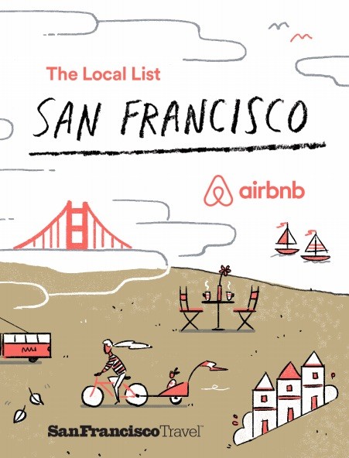](https://s3-us-west-2.amazonaws.com/courses-images-archive-read-only/wp-content/uploads/sites/903/2016/02/23230505/SFLocalList-MT-090115_r11_pdf.jpg)**

**[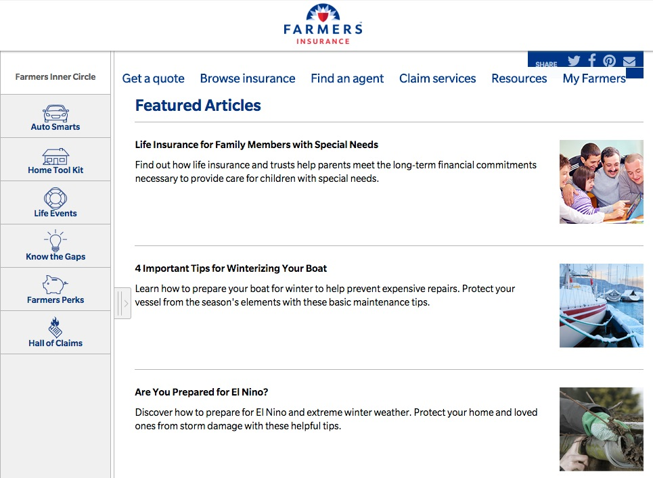](https://s3-us-west-2.amazonaws.com/courses-images-archive-read-only/wp-content/uploads/sites/903/2016/02/23230507/Farmers_Insurance_Inner_Circle.jpg)**

Articles and tips on Farmers Insurance Web site.

**[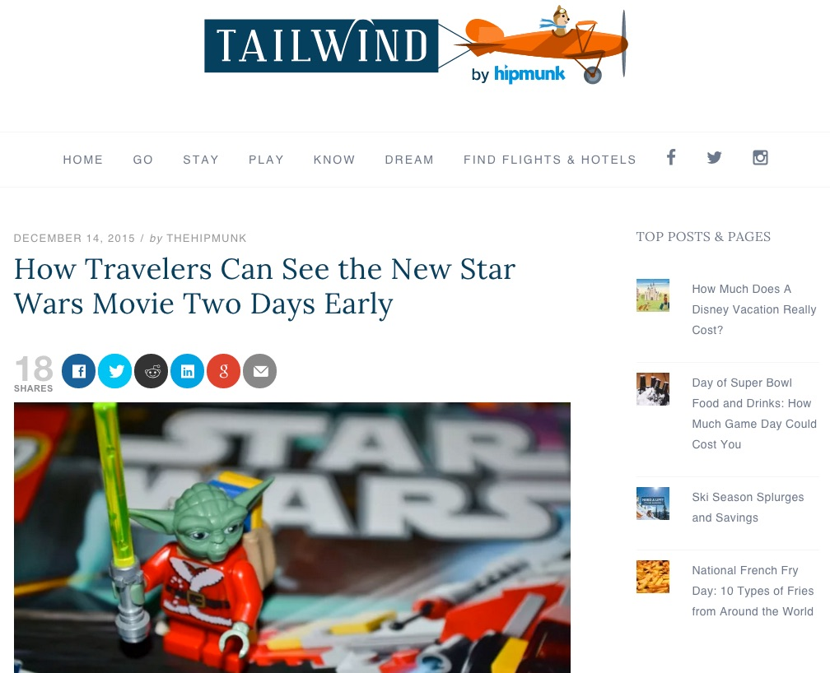](https://s3-us-west-2.amazonaws.com/courses-images-archive-read-only/wp-content/uploads/sites/903/2016/02/23230503/How_Travelers_Can_See_the_New_Star_Wars_Movie_Two_Days_Early_-_Tailwind_by_Hipmunk.jpg)**

**Advantages and Disadvantages of SEO and Content Marketing**

Internet search is a fact of life in the modern world. It is a critical tool for customer decision making in B2B and B2C markets. Practicing the basic tenets of SEO helps an organization get into the search-engine fray. When marketers do it skillfully, they can easily track the results, see what works, and adjust course to improve outcomes. When organizations generate high-quality content, it can be relatively inexpensive to achieve great SEO results, particularly as search engines themselves increasingly reward the “real deal”: good information and true substance targeted to a specific audience.

While SEO and content marketing are powerful tools, they are also rather like puppies that need ongoing feeding and care. Both require regular monitoring to check whether they are effective and need refreshing. The Internet is a crowded and competitive place, where organizations from around the globe can compete with one another for attention and customer loyalty. It takes persistence and hard work to get on top of the Internet content world and stay there.

**Digital Marketing: Social Media**

**Social Media Marketing**

Social media marketing is the use of online applications, networks, blogs, wikis, and other collaborative media for communicating brand messaging, conducting marketing, public relations, and lead generation. Social media are distinctive for their networking capabilities: they allow people to reach and interact with one another through interconnected networks. This “social” phenomenon changes the power dynamic in marketing: no longer is the marketer the central gatekeeper for all communication about a product, service, brand, or organization. Social media allows for organic dialogue and activity to happen directly between individuals, unmediated by a company. Companies can (and should) listen, learn, and find ways to participate authentically.

Social media marketing focuses on three primary objectives:

1. **Creating buzz:** Developing and publishing messages (in a variety of formats–e.g., text, video, and images) that is disseminated via user-to-user contact
2. **Fostering community:** Building ways for fans to engage with one another about a shared interest in a brand, product, or service
3. **Facilitating two-way communication:** Online conversations are not controlled by the organizations. Instead, social media promotes and encourages user participation, feedback, and dialogue

**How Social Media Marketing Works**

Organizations have opportunities to engage in social media for marketing purposes in several ways: paid, earned, and owned social media activity.

* **Paid:** Paid social media activity includes advertisements on social media (placed in various locations), sponsored posts or content, and retargeting advertisements that target ads based on a consumer’s previous actions. This type of social media activity is best suited for sales, lead generation, event participation, and incorporation into IMC campaigns.
* **Earned:** Earned social media activity involves news organizations, thought leaders, or other individuals who create content about an organization. It is particularly suited to supporting public relations efforts.
* **Owned:** Owned social media activity happens through social media accounts that an organization owns (e.g., Facebook page, Twitter handle, Instagram name, etc.). This activity is ideal for brand awareness, lead generation, and goals around engaging target audiences.

Effective use of social media to reach your target audience requires more effort by an organization than the traditional marketing methods. Not only must an organization create unique content and messaging, but it must be prepared to engage in two-way communication regarding the content that it produces and shares on social media. To be effective at using social media to reach target audiences, an organization must:

* **Create unique content, often.** Social media, unlike traditional methods, cannot rely on static content. An organization must regularly publish new, unique content to stay relevant on any social media platform.
* **Ask questions.** To foster engagement, an organization must solicit feedback from users, customers, and prospects. This is critical to creating conversation, insight, and discussion on social media platforms.
* **Create short-form media.** Most social media platforms have character limits per post. Users on social media expect to be able to scan their feed. Long posts (even within character limits) tend to underperform. The more succinct an organization can be, the better.
* **Try different formats.** Most social media platforms provide users with the option to add images and video to text. Social media is becoming an increasingly visual medium, where content that performs the best usually includes an image or video. Try to convert messages into images and video when possible for maximum reach.
* **Use a clear, immediate call to action.** Social media works best for achieving marketing goals with a clear call to action that a user can do immediately from their computer or mobile device. Examples include 1) Web traffic (click-through), 2) downloads of content (e.g., white papers, articles, etc.), 3) online purchases, and 4) engagement (comment, like, share, view, read).

**Common Social Media Marketing Tools**

What’s hot in social media is a moving target, but the following table provides a listing and description of primary social media platforms.

| **Tool** | **Description** |
| --- | --- |
| Blogs | Long- or short-form medium for communicating with audiences |
| YouTube | Video-hosting social media site |
| Twitter | Short-form (140 character) “microblogging” medium that is intended for text and image sharing |
| Facebook | Long-form (up to 2,000 characters per post) medium for sharing text, images, videos, and other multimedia content |
| Instagram | Image-based social network that is intended as a visual medium. Does not have capabilities to drive click-through rate (CTR) because posts offer no link option |
| Google+ | Long-form medium for sharing text, images, videos, and other multimedia content |
| Pinterest | Medium for sharing photos and visual content categorized by theme |
| LinkedIn | Long- or short-form medium for sharing text, images, videos, and other multimedia content targeted to the business community |

**Advantages and Disadvantages of Social Media Marketing**

The advantages and benefits of social media marketing focus heavily on the two-way and even multidirectional communication between customers, prospects, and advocates for your company or brand. By listening and engaging in social media, organizations are better equipped to understand and respond to market sentiment. Social media helps organizations identify and cultivate advocates for its products, services, and brand, including the emergence of customers who can become highly credible, trusted voices to help you sell. Unlike many other forms of marketing, social media are very measurable, allowing marketers to track online customer behavior and how target audiences respond to content created by the organization. Social media offers a virtually unlimited audience for communicating and sharing key messages in the market. It also offers marketers the ability to relatively easily target and test the effectiveness of content using the various targeting capabilities of social media for location, interests, income, title, industry, and other sociographic differentiators.

Social media also carry a number of inherent challenges. Social media are dynamic environments that requires significant effort to monitor and stay current on. It is also difficult to continually create “share-worthy” content. The variety of social media tools makes it a challenge to understand which platforms to use for which target audiences and calls to action. Crisis communications can be difficult, too, particularly in the public environment of social media, in which it is difficult to contain or control communication. This means it can be difficult to mitigate the impact of a crisis on the brand.

One of the biggest challenges facing organizations is determining who in the organization should “own” the social media platforms for the organization. Too few hands to help means the burden of content creation is high on a single individual. However, too many people often results in duplication of efforts or conflicting content.

**Expert Insight on Using Social Media: JetBlue**

Airline carrier JetBlue has received attention and accolades for its effective use of social media to foster two-way communication with customers. In this video, JetBlue’s head of social media strategy, Morgan Johnston, explains the company’s approach to social media and how it complements other corporate and marketing communication activity. He also shares insights about how the company used social media to manage crisis communications and respond to customers during Hurricane Sandy, when extreme weather conditions hit the company’s northeastern U.S. travel routes hard.

**Guerrilla Marketing**

**Thinking Outside the Box**

Guerrilla marketing is a relatively new marketing strategy that relies on unconventional, often low-cost tactics to create awareness of and goodwill toward a brand, product, service, or even a company. The term “guerrilla marketing” itself comes from Jay Conrad Levinson, who coined the term in his 1984 book *Guerrilla Advertising*. Though “guerrilla” has military connotations (the word means “little war), guerrilla promotion strategies often combine elements of wit, humor, and spectacle to capture people’s attention and engage them in the marketing act. Guerrilla marketing is memorable. And, like the renegade militias it was presumably named for, unexpected.

Practitioners of guerrilla marketing today have used other words to describe it: *disruptive, antiestablishment, newsworthy*, and *a state of mind.*By its nature, guerrilla marketing defies precise description, so it may be worthwhile to view an example before going further.

**Classic Guerrilla: Nike Livestrong at the Tour de France**

Although this campaign was a full-blown IMC effort, at its core it was really a memorable guerrilla marketing stunt: the spectacle of painting the streets of France during the world-famous Tour de France bicycle race in 2008. Designed to generate awareness for Nike, the nonprofit Livestrong Foundation, and the cause of fighting cancer, marketers succeeded in sharing inspiring messages of hope with their target audiences: athletes, sports enthusiasts and people affected by cancer, particularly young people.

**Telltale Signs of Guerrilla Marketing**

Guerrilla marketing campaigns can be very diverse in their approach and tactics. So what do they have in common? Guerrilla marketing often has the following characteristics:

* It’s imaginative and surprising, but in a very hip or antiestablishment way
* Doesn’t resemble a traditional marketing initiative, such as a straightforward print or TV advertising campaign
* Uses combinations of different marketing communications tactics, in creative ways
* Is experiential, drawing in the target audience to participate
* Takes risks in what it aspires to accomplish, even if it might ruffle some feathers
* Is not 100 percent approved by the establishment (i.e. the city, the event planners, the powers that be)

**[](https://s3-us-west-2.amazonaws.com/courses-images-archive-read-only/wp-content/uploads/sites/903/2016/02/23230525/mcdonalds-fries-crosswalk-guerrilla-marketing-ad_jpg__1100%C3%97734_.jpg)**

Clever guerrilla marketing campaign: McDonald’s fries crosswalk

**[](https://s3-us-west-2.amazonaws.com/courses-images-archive-read-only/wp-content/uploads/sites/903/2016/02/23230510/discoveryshark_jpg__1771%C3%97930_.jpg)**

Successful guerrilla marketing campaign: AUSTAR’S Discovery Channel in Australia placed “shark-bitten” surfboards around popular Sydney beaches in an effort to create buzz for its upcoming Shark Week documentary. Source: https://malteholm.wordpress.com/tag/shark-week/

**When to Use Guerrilla Marketing**

This edgy marketing approach focuses on two goals: 1) get media attention, and 2) make a positive and memorable connection with your target audience. Many noteworthy guerrilla campaigns, like Nike Livestrong, focus on creating an experience that embodies the spirit of the brand. Often these projects invite people who encounter the campaign to become co-conspirators in achieving the campaign’s vision and reach.

Guerrilla marketing experts assert that this technique can work for virtually any brand or organization, so long as the organization doesn’t mind taking some risks, and so long as the project is true to who you are and what you represent. The right concept for the guerrilla marketing effort should capture your organization’s authentic voice and express what is unique about your brand identity. At some point you may be asked to stand up for your actions if you’re called onto the carpet, so you need to believe in what you are doing. Guerrilla marketing is particularly suited to small, imaginative organizations that may not have much money but have a burning desire to do something memorable—to make an entrance or a splash. Severe budget constraints can encourage creative teams to be very inventive and original

Because it is inherently *spectacle*, guerrilla marketing tactics work very well for building brands and generating awareness and interest in an organization, product, service, or idea. They aim to put a company on the map–the mind-share map. It’s interesting that guerrilla marketing often calls on the audience to engage or take action, but turning participants into a paying customers may not be the goal. However, successful guerrilla marketing can make audiences undergo a kind of “conversion” experience: if the impact is powerful enough, it can move consumers further along the path towards brand loyalty.

**Guerrilla Marketing Tactics: The Usual Suspects**

As you saw in the example of the lamppost transformed into a McDonald’s coffeepot, all kinds of spaces and urban environments present opportunities for the guerrilla marketer. In fact, guerrilla marketing initiatives can be executed offline or online. Some companies feel that an edgy, unexpected online campaign with creative guerrilla elements is a little safer than executing a project in the bricks-and-mortar world.

It goes against the very notion of guerrilla marketing to establish a set of tactics or practices that are “conventional” or “typical.” However, the following list describes some examples of guerrilla marketing tactics from noteworthy campaigns, which will give you an idea of what’s been used in the past.

|  |  |
| --- | --- |
| **Guerrilla Tactic** | **Description** |
| Graffiti | Graffiti marketing, a subset of guerrilla marketing, turns walls, alleys, and streets into larger-than-life canvases for marketing activity. |
| Stencil graffiti | Use of stencils to create repeated works of graffiti, with the stencils enabling the project team to rapidly recreate the same work in multiple locations. Stencils tend to be smaller-scale and simpler than classic graffiti art. |
| Undercover, or stealth marketing | Use of marketers or paid actors to go “undercover” among peers to engage unsuspecting people in a marketing activity of some sort. For example, attractive actors are paid to strike up conversations, rave about a new mobile device, and then ask people to take a photo using the device, so that they get hands-on experience with the product in question. |
| Stickers | Inventive use of stickers as a temporary medium for creating an image, posing an illusion, or conveying a message |
| Flash mobs | A group of people organized to perform an action at a predetermined place and time; usually they blend in with bystanders initially and then join the “mob” activity at the designated moment, as in the Do Re Mi video, above. |
| Publicity stunts | Extraordinary feats to attract the attention of the general public, as well as media |
| Treasure hunts | Placing a series of online and offline “treasure hunt” clues in an urban environment and inviting target audiences to participate in the hunt to win prizes and glory |
| Sham events | Staging an activity or event that appears real, but in fact is a fake, for the purposes of drawing attention and making a statement |

Despite the irreverent, antiestablishment spirit of guerrilla marketing, marketers should use good judgment about seeking permission from building owners, city managers, event planners, or others in a position of authority, to avoid unpleasant or unnecessary complications. Some coordination, or even a heads-up that something is happening, can go far toward earning goodwill and a cooperative spirit in the face of an unexpected spectacle.

**Advantages and Disadvantages of Guerrilla Marketing**

Guerrilla marketing has several notable advantages. It can be inexpensive to execute—it’s often much cheaper than traditional advertising when you consider the number of impressions and amount of attention generated. It encourages creativity and inventiveness, since the goal is to create something novel and original. Guerrilla marketing is about buzz: it is designed for viral sharing, and it taps into powerful word-of-mouth marketing as people share their memorable guerrilla-inspired impressions and experiences with friends and acquaintances. A guerrilla marketing phenomenon can take on a life of its own and live in the memories of the people it affected long after the actual event is over. Finally, when executed effectively, guerrilla tactics are designed with media and publicity in mind. Media attention can snowball and generate a larger-than-expected “bounce” as local or even national outlets choose to cover these events.

As suggested above, guerrilla marketing also carries some disadvantages and risks. When an (apparently) spontaneous activity springs up in a public space, property owners, the police, and other authorities may object and try to interfere or stop the event. Unexpected obstacles can arise, which even the best-laid plans may have missed: weather, traffic, current events, timing, etc. Some audiences or bystanders may misinterpret what is happening, or even take offense at provocative actions or messages. When guerrilla projects are cloaked in secrecy or mystery, people may become uncomfortable or fearful, or the aura of mystery may cause them to interpret the message and goals incorrectly. Similarly, if people feel they have been duped by a guerrilla marketing activity, they may come away with negative impressions. Compared to traditional marketing, guerrilla tactics are definitely riskier. Then again, the rewards can be brilliant, when things go as planned.